BUG REPORT

Project Name: AI CERTs Learner Portal
Application URL: https://v2learner.aicerts.ai/
Module: (e.g., Sign Up, OTP Verification, Dashboard)
Tested By: Sanika Mandaokar
Date: 2025-10-23
Environment: Web Browsers (Chrome, Edge, Brave)

Bug Summary Table
Bug ID | Title/Short Description | Module | Steps to Reproduce | Expected Result | Actual Result | Severity | Priority | Status | Comments
BUG01 | First Name accepts special characters and numbers | Sign Up | 1. Open browser 2. Enter portal URL 3. Click sign up 4. Enter 123456 in First Name | Should not accept numbers or special characters. Error message must be shown. | Field accepts input with no error. No validation message displayed. | Major | High | Open | Validation  issue found
BUG02 | Last Name field accepts invalid input | Sign Up | 1. Open browser 2. Enter portal URL 3. Click sign up 4. Enter abc12rt in Last Name | Should only accept alphabets. Should not accept numbers or special characters. | Field accepts invalid input. Error message not displayed. | Major | High | Open | Validation  issue found
BUG03 | First and Last Name fields accept same value | Sign Up | 1. Open browser 2. Enter portal URL 3. Click sign up 4. Enter same data in both fields | Should not allow same value for First and Last Name. "Names cannot be same.” error | No error displayed. Form allows same values. | Major | High | Open | Should display  validation
BUG04 | Cancel button redirects instead of clearing form | Sign Up | 1. Go to Sign Up page 2. Fill in valid details 3. Click Cancel button | All fields should clear; user stays on Sign Up page. | Form data not cleared. Redirected to login. | Major | High | Open | User flow/  usability impact
BUG05 | OTP not blocked after 5 wrong attempts | OTP Verify | 1. Go to OTP verification 2. Enter incorrect OTP 5 times 3. Try to enter OTP again | After 5 incorrect attempts, portal should block further tries or show error message | System still allows entering OTP infinitely. | Critical | High | Open | Security/  Usability  risk

Bug Report: BUG05
Bug ID: BUG05
Title: OTP System Does Not Block After Repeated Wrong Attempts
Module: OTP Verification
Reported By: Sanika Mandaokar
Date Reported: 2025-10-23
Environment: AI CERTs Learner Portal (Web Browsers: Chrome, Edge, Brave)
Severity: Critical
Priority: High
Status: Open

Description
The OTP verification system allows unlimited entry attempts even after multiple consecutive failures. This presents a significant security risk, as it enables brute-force attacks on the verification process and could compromise user accounts.

Steps to Reproduce
- Access the AI CERTs Learner Portal and navigate to the OTP verification screen after sign-up.
- Enter an incorrect OTP code and submit.
- Repeat step 2 at least five times using different invalid codes.
- Attempt to enter and submit additional OTP codes beyond the fifth attempt.

Expected Result
After five incorrect OTP attempts, the system should:
- Block further OTP entries from the user.
- Display an error message, such as “You have exceeded the maximum number of attempts. Please try again later or contact support.”
- Prevent additional OTP submissions during the blocked time or until further action by support.

Actual Result
- The system allows unlimited attempts to enter and submit OTP codes.
- No warning, block, or error message appears after multiple failures.
- Security is compromised as a result.
Impact
- Security Risk: This flaw makes the portal vulnerable to brute-force attacks on OTP, potentially allowing unauthorized access.
- User Experience: Users may be confused by lack of feedback after repeated failure, and attackers are not deterred.

Attachments
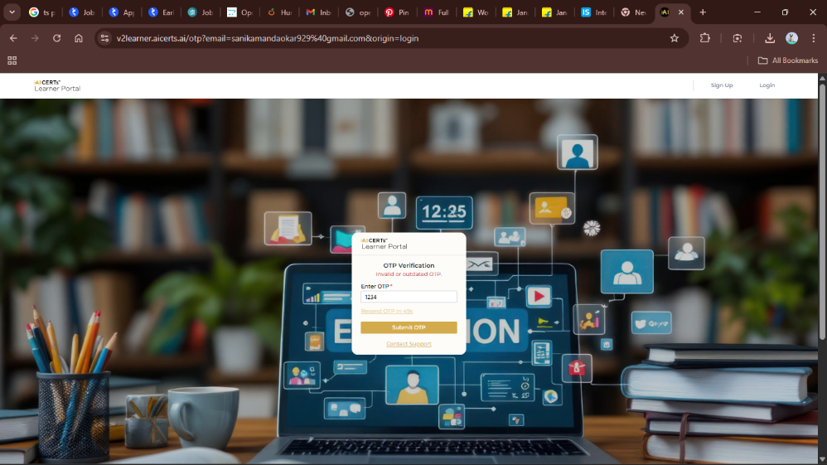

Recommendations
- Implement a lockout mechanism after a fixed number of failed OTP entries (e.g., 5 attempts).
- Display a clear error message to the user when blocked.
- Consider temporary time-based lockout or CAPTCHA to prevent automated attacks.

Conclusion
This is a critical security and usability defect. Immediate attention is recommended to mitigate risk before public release.

